BUSINESS INSIGHT REPORT
GLOBAL SALES & FINANCIAL PERFORMANCE

Dataset Name:
GLOBAL_SALES & FINANCIAL PERFORMANCE
Student Name: Monish Kumar .N
Course / Class:B.com Fintech With Ai
Date:

1. Introduction
This Business Insight Report presents an analysis of the Global Sales & Financial Performance dataset through an interactive sales dashboard. The purpose of the report is to understand overall sales, profit, cost, quantity and order performance and to identify useful patterns across products, categories, months, regions and employees.
The dashboard provides a simple visual view of business performance and helps management make data-driven decisions. The analysis focuses on key performance indicators (KPIs), product categories, monthly sales trends, regional contribution and employee performance. Based on these findings, practical recommendations are provided for inventory planning, marketing, regional growth, employee performance, product portfolio and customer targeting.

2. Dashboard Overview
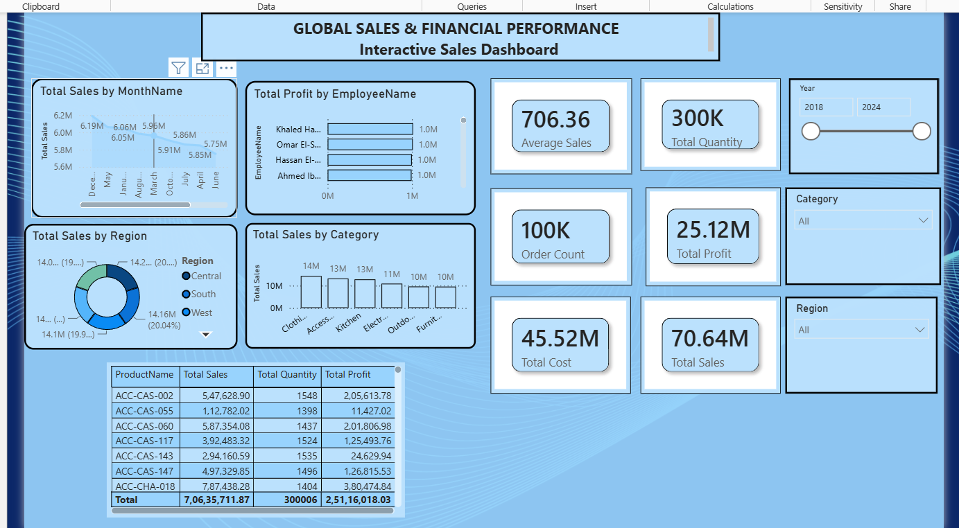
Figure 1: Interactive Sales Dashboard – Global Sales & Financial Performance
The dashboard combines charts, KPI cards, filters and a detailed product table in one view. It allows users to examine performance for different years and categories and to compare sales across months, regions, product categories and employees. The main KPI cards show Average Sales of 706.36, Total Quantity of approximately 300K, Order Count of approximately 100K, Total Profit of 25.12M, Total Cost of 45.52M and Total Sales of 70.64M.

3 KPI Analysis.
The KPI section gives a quick summary of the financial and operational position of the business. Total Sales are approximately 70.64 million, while Total Profit is approximately 25.12 million. Total Cost is approximately 45.52 million. This indicates that the business generates a substantial profit after covering its reported costs.
The dashboard also reports around 300K units of total quantity and around 100K orders. The Average Sales KPI is 706.36. Together, these measures suggest a large volume of transactions and provide a useful starting point for evaluating business efficiency.
An important management focus should be to protect the existing profit level while controlling costs. Management can also monitor average sales and order volume regularly to identify changes in customer purchasing behaviour.
KPI | Dashboard Value | Business Meaning
Total Sales | 70.64M | Overall revenue generated
Total Profit | 25.12M | Overall profit contribution
Total Cost | 45.52M | Cost incurred against sales
Total Quantity | 300K | Approximate units sold
Order Count | 100K | Approximate number of orders
Average Sales | 706.36 | Average sales measure shown by dashboard

4. Product Category Performance Analysis
The category chart shows that Clothing has the highest sales among the displayed categories at about 14M. Accessories and Kitchen follow at about 13M each. Electronics is around 11M, while Outdoor and Furniture are around 10M each.
The results show that the business has a relatively broad product portfolio, but Clothing is the strongest category in the displayed dashboard. Categories with slightly lower sales should not automatically be removed; instead, management should examine their profit margins, customer demand and growth potential.
The business can increase performance by maintaining sufficient stock for high-demand categories and using targeted promotions for categories with lower sales. Cross-selling can also be used, such as recommending accessories with clothing or complementary products with electronics.

5. Monthly Sales Trend Analysis
The monthly sales chart shows sales values broadly within the range of about 5.75M to 6.19M across the displayed months. December records the highest visible value at approximately 6.19M, followed by May at about 6.06M and January at about 6.05M. June is among the lower displayed values at about 5.75M.
The monthly movement indicates that sales are relatively stable, but some months perform better than others. December's stronger sales may indicate increased seasonal or year-end purchasing. Such patterns can help management prepare inventory and promotional campaigns before high-demand periods.
For better planning, the business should compare monthly sales with profit and quantity rather than using sales revenue alone. A month with high sales but low profit may require a review of discounts, product mix and operating costs.

6. Regional Sales Analysis
The regional donut chart compares sales contribution across Central, South and West regions. The displayed values are close to one another, with the West region showing approximately 14.16M (20.04%) in the visible label. This suggests that sales are distributed across regions rather than being concentrated entirely in one location.
A balanced regional contribution can reduce dependence on a single market. However, management should identify the exact sales, profit and growth rate for each region before making expansion decisions. Regions with strong sales and profit can receive additional investment, while weaker regions may need localized marketing and customer research.
Regional performance can also be improved by studying differences in product preferences, pricing, delivery performance and customer segments. This will help the company develop region-specific strategies instead of using the same approach everywhere.

7. Employee Performance Analysis
The employee performance chart ranks employees based on total profit. The visible top employees—Khaled Ha..., Omar El-S..., Hassan El-..., and Ahmed Ib...—each contribute approximately 1.0M in total profit in the displayed view.
This indicates that the leading employees make a meaningful contribution to profitability. Management can study the practices of high-performing employees, such as customer handling, sales conversion and product knowledge, and share successful methods with the wider team.
Employee performance should be evaluated using multiple measures, including sales, profit, number of orders, average order value and customer retention. This provides a fairer assessment than using sales alone and can support training, recognition and incentive programmes.

8. Business Recommendations
Inventory Planning: Maintain higher stock levels for high-performing categories such as Clothing and prepare inventory in advance of stronger sales months such as December. Use sales history to reduce both stock-outs and excess inventory.
Marketing Strategy: Use seasonal campaigns during stronger months and targeted promotions for categories with lower sales. Combine products through bundles and cross-selling to increase order value.
Regional Expansion: Compare regional sales, profit and growth before expanding. Strengthen regions with good profitability and test localized campaigns in regions with weaker performance.
Employee Performance: Recognize high-performing employees and identify the methods behind their results. Provide targeted training and incentives using sales, profit and customer-related measures.
Product Portfolio: Protect the leading Clothing category while reviewing the profitability and growth potential of Accessories, Kitchen, Electronics, Outdoor and Furniture. Expand products that have strong demand and healthy margins.
Customer Targeting: Use category, regional and monthly purchasing patterns to create customer segments. Offer personalized recommendations, bundles and promotions based on customer interests and buying behaviour.
Cost & Profit Control: Because the dashboard reports approximately 45.52M in total cost and 25.12M in total profit, management should regularly review major cost areas and protect profit margins while growing sales.

9. Conclusion
The Global Sales & Financial Performance dashboard provides a clear overview of the business's sales and financial position. The dashboard reports approximately 70.64M in total sales, 25.12M in total profit, 45.52M in total cost, 300K in quantity and 100K orders. Clothing is the strongest displayed product category, while monthly sales remain relatively stable with December showing the highest visible monthly value.
The analysis also shows that sales are distributed across regions and that several employees contribute strongly to profit. Overall, the business can improve performance by using data for inventory planning, targeted marketing, regional decisions, employee development and product portfolio management. Regular monitoring of these KPIs will help management respond quickly to changes and support sustainable business growth

